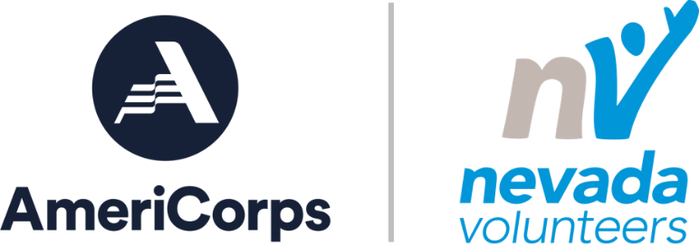

Nevada Volunteers
2022-2023 Volunteer Generation Fund Grant Application
Please type text into form. Fields will expand automatically. Save form as Word document to submit.
Applicant Organization Name:
Applicant Organization Address:
City, State, Zip
Applicant Organization Tax ID:
Applicant Organization DUNS Number:
Applicant Organization UEI Number:
Project Manager Name:
Project Manager Phone:
Project Manager Email:
Amount Requested (Max. $25,000):
Amount of Matching Funds:
Total Number of Employees
Total Number of Volunteers (annually):
Total Annual Operating Budget: | □ $100,000 or less  □ $100,000 - $250,000  □ $250,000 - $500,000  □ $500,000 - $750,000  □ $500,000 - $750,000  □ $750,000 - $1,000,000  □ $1,000,000 or greater
Do you receive any other federal funding? | □ Yes □ No
Have you worked with federal funding in the past? | □ Yes □ No

ORGANIZATION OVERVIEW
Briefly describe your organization and the community need being addressed. Be clear and concise (1-2 paragraphs only).

VOLUNTEER PROGRAM SUMMARY
Briefly describe your volunteer program. Be clear and concise (1-2 paragraphs only).

VOLUNTEER PROGRAM NEED
Describe your volunteer program needs, why you are applying for this grant, and what you hope to achieve.

PROJECT DESIGN
Describe the goals and objectives of your organization's proposal, what intervention(s)you are addressing and any anticipated outcomes. Applicants must identify at least one intervention as mentioned in the Application Review section of the VGF NOFO. Additional projects/interventions can be included that lead to expanding your organization's capacity to manage, retain and recognize volunteers, adopt and execute generally accepted best practices in managing volunteers, and to better sustain a successful volunteer program.

PROJECT IMPACT
Describe the extent to which your proposed project will address the volunteer program need identified above and positively impact your organization's volunteer activities, including capacity building and program sustainability.

ORGANIZATIONAL CAPACITY
Describe the extent to which the organization has the experience, staffing, and management structure to plan, implement, and evaluate the proposed project.

BUDGET NARRATIVE
Briefly describe how proposed funds will be utilized (staff, travel, supplies and materials) and source of any matching collateral (cash or in-kind). Complete the budget template provided and submit it with this application form.

General Terms and Conditions
- If funded, Applicant agrees to complete the project described in this application during the project period of January 1 – August 31, 2023.
- Applicants selected for funding will be required to complete a grant award agreement.
- Grantees must document their project by completing a mid-cycle project report due no later than May 30, 2023, and a final project report, no later than September 30, 2023.
- Grantees must provide initial funding for all project costs and agree to submit copies of expenditures after-the-fact for reimbursement, on a monthly basis throughout the grant cycle with final reimbursement requests submitted no later than September 30, 2023.
- Nevada Volunteers reserves the right to reduce or withhold grant funds if the project is not fully completed, if Grantee fails to report by the due date or properly document costs incurred in the project.
- Grantees agree to complete pre and post funding assessments, participate in monthly one on one calls, and attend offered training and technical assistance webinars and in person trainings.
- Please refer to the Notice of Funding Opportunity for further terms, conditions and regulations.
- Entities must have a valid SAM registration and [DUNS and/or Unique Entity Identifier] to receive an award. Applicants can obtain a DUNS number at no cost by calling the DUNS number request line at (866) 705-5711 or by applying online at the DUNS Request Service. All applicants must also register with the System for Award Management (SAM) at https://www.sam.gov/SAM/. Nevada Volunteers is happy to assist organizations in this process. For guidance on registering, contact Shannon Arimura at shannon@nevadavolunteers.org.

Applicant Signature | Date
Application Due Date: September 23, 2022 at 5:00 PM
Submit application to Shannon@nevadavolunteers.org

