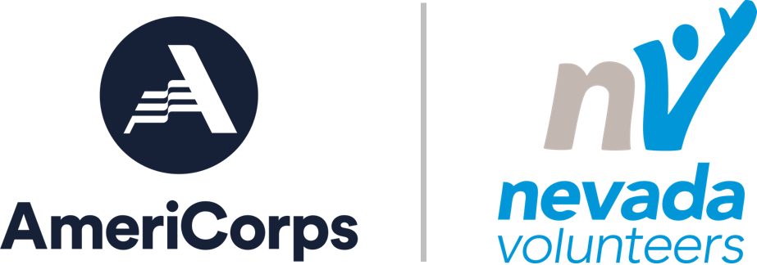

2021 Volunteer Generation Fund
Volunteer Recognition Grant Application
Please type text into form. Fields will expand automatically. Save form as Word document to submit.
Applicant Organization Name:
Applicant Organization Address:
City, State, Zip
Applicant Organization Tax ID:
Project Manager Name:
Project Manager Phone:
Project Manager Email:
Amount Requested (Max. $2,500):
Number of Youth Volunteers:
Total Number of Volunteers (annually):

Describe your organization, its volunteer program and impact in the community.

If awarded how will the funds be utilized to recognize and celebrate your volunteers?

If awarded how will the funds impact and/or enhance your organizations capacity to recognize and celebrate your volunteers?

Indicate an estimated amount by category below and provide general description of anticipated costs. An itemized budget is not required. Actual costs will be documented when you submit your final project report.
Category | Amount | Description
Supplies & Materials
(tools, paint, mulch, etc.)
Volunteer Support
(food, promotional items, recruitment)
TOTAL REQUEST

General Terms and Conditions
- If funded, Applicant agrees to complete the project described in this application during the project period of July 1 – August 31, 2021.
- Applicants selected for funding will be required to complete a grant award agreement.
- Grantees must document their project by completing a final project report, including photos and/or video, no later than September 15, 2021.
- Grantees must provide initial funding for all project costs and agree to submit copies of expenditures after-the-fact for reimbursement, no later than September 15, 2021.
- Nevada Volunteers reserves the right to reduce or withhold grant funds if the project is not fully completed, if Grantee fails to report by the due date or properly document costs incurred in the project.
- Entities must have a valid SAM registration and [DUNS and/or Unique Entity Identifier] to receive an award. Applicants can obtain a DUNS number at no cost by calling the DUNS number request line at (866) 705-5711 or by applying online at the DUNS Request Service. All applicants must also register with the System for Award Management (SAM) at https://www.sam.gov/SAM/. Nevada Volunteers is happy to assist organizations in this process. For guidance on registering, contact Shannon Moore at shannon@nevadavolunteers.org.
Applicant Signature | Date
Application Due Date: May 31, 2021 at 5:00 PM
Submit application to Shannon@nevadavolunteers.org

