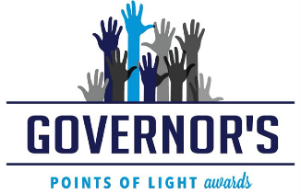
2017 Governor’s Points of Light Awards – Sponsorship Reservation
Thursday, October 5, 2017 ~ 11:30 am to 1:30 pm
The Flamingo in Las Vegas
Company Information
Company Name (as it will appear in event literature): ______________________________________

Primary Contact Name & Title: ___________________

Address: _____________________________________________________________________________

City: _____ State: ______ Zip: ____________

Phone: Email: ___________________
Sponsorship Levels (sponsorship deadline is August 31, 2017)
Visionary Sponsor……………………..$10,000
Platinum Sponsor…………………..…$7,500
Gold Sponsor……………………..……$5,000
Silver Sponsor…………………….$2,500
Sponsor a Finalist………….……..$1,500
Sponsor a Table…………………..$1,250

- In-Kind Sponsor (for approved donations only) – Call Nevada Volunteers (775) 825-1900 for more information
Table Purchase (deadline for table purchase is October 1, 2017)

Corporate Table of 10…………….$1,250.00 Non-Profit Table of 10……………….$650.00
Purchase Advertising Only in the Event Program (deadline for ads is August 31, 2017)

- 2 Page Spread ad……….$1,500
- Full page ad……….……..$1,000

- Half page ad……………...$750.00
- Quarter page ad ..……….$500.00

*Contact Nevada Volunteers for full ad details and specifications
Method of Payment

- Check enclosed (Make check payable to Nevada Volunteers, 639 Isbell Rd., Ste. 220, Reno, Nevada 89509)
- Please invoice me
- Credit Card Payment – Please contact our office at (775) 825-1900
Check is the preferred method of payment. Credit Card payments result in decreased revenue due to processing fees.
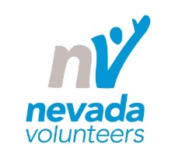
Mail, fax or email sponsorship form to:
Nevada Volunteers, Attn: Amber Martin-Jahn, Executive Director
639 Isbell Road, Suite 220, Reno, NV 89509
Office: (775) 825-1900 or Fax: (775) 825-1901
Email: info@nevadavolunteers.org

