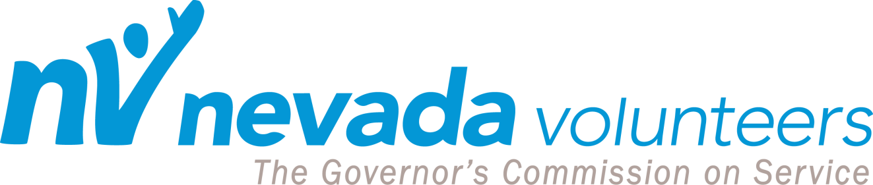

2017 Governor’s Points of Light Awards - Silent Auction Commitment Form

Yes! We plan to donate the following item:

Item Description:

Donated by:
Company Name: |  | Contact:
Address: | City: | State: | Zip:
Phone: | E-Mail:

Estimated Value of Item: _______________

No, we are unable to donate at this time.

All donations will be promoted on our statewide online auction site if information is received by September 15, 2017. All silent auction items must be received in our office by September 15, 2017. Please enclose this form with your silent auction item and send to:

Nevada Volunteers
639 Isbell Rd Suite #220
Reno, NV 89509
To coordinate a silent auction item pick up, please call:

Nevada Volunteers – Terry Bell
(775) 825-1900
tbell@nevadavolunteers.org

Thank you for supporting volunteerism in Nevada!

Nevada Volunteers is a registered 501 (c) 3 nonprofit corporation with the Secretary of State pursuant to Section 3 of AB60 and all donations may be tax deductible pursuant to the provisions of section 170c of the Internal Revenue Code of 1986, 26 U.S.C. 170.c., Tax ID # 88-0377269.

